PHP ASSIGNMENT

**TOPIC – SQL TASK 2**

**CREATE DATABASE:-**

**CREATE** **DATABASE** sqltask2;

**CREATE TABLE:-**

**CREATE** **TABLE** SALES_PERSON(SNO **INT**(10)**PRIMARY** **KEY**,

SNAME **VARCHAR**(50) **NOT** **NULL**,

CITY **VARCHAR**(20) **NOT** **NULL**,

COMM **FLOAT**(20) **NOT** **NULL**);

**INSERT DATA:-**

**INSERT** **INTO** sales_person(SNO,SNAME,CITY,COMM)

**VALUES**

(1001,"PEEL","LONDON","0.12"),

(1002,"SERRES","SAN JOSE","0.13"),

(1003,"AXELROD","NEW YORK","0.1"),

(1004,"MOTIKA","LONDON","0.11"),

(1007,"RAFKIN","BARCELONA","0.15");

TABLE – SALES PERSON

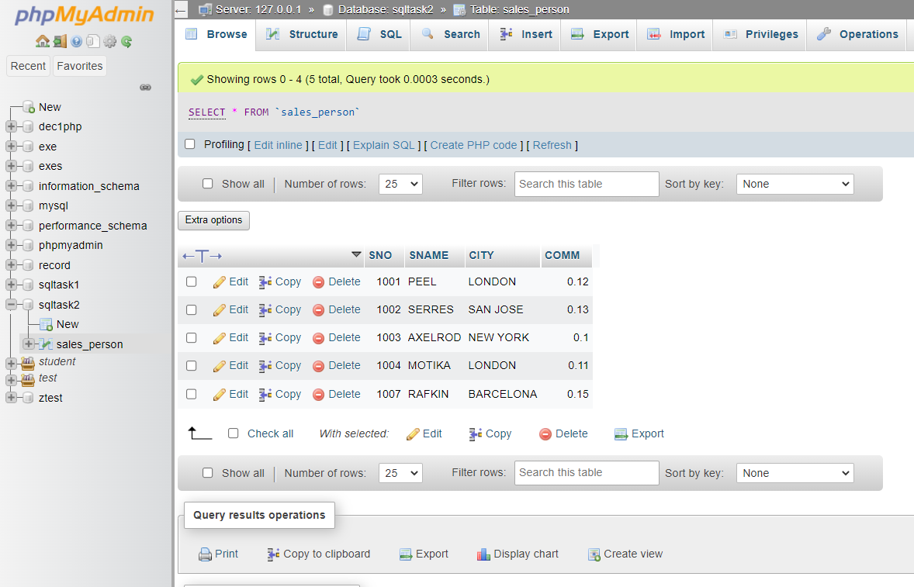

**CREATE TABLE:-**

**CREATE** **TABLE** CUSTOMER(CNM **INT**(10)**PRIMARY** **KEY**,

CNAME **VARCHAR**(50) **NOT** **NULL**,

CITY **VARCHAR**(20) **NOT** **NULL**,

RATING **INT**(10) **NOT** **NULL**,

SNO **INT**(10) **NOT** **NULL**);

**INSERT DATA:-**

**INSERT** **INTO** customer(CNM,CNAME,CITY,RATING,SNO)

**VALUES**

(201,"HOFFMAN","LONDON",100,1001),

(202,"GIOVANNE","ROME",200,1003),

(203,"LIU","SAN JOSE",300,1002),

(204,"GRASS","BARCELONA",100,1002),

(206,"CLEMENS","LONDON",300,1007),

(207,"PEREIRA","ROME",100,1004);

TABLE – CUSTOMER

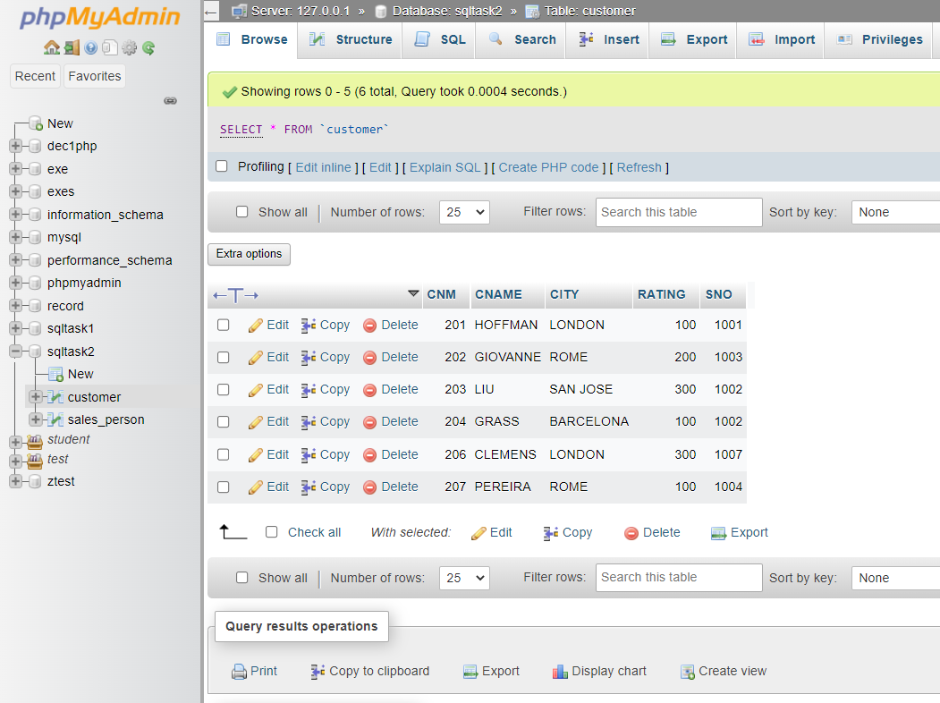

**CREATE TABLE:-**

**CREATE** **TABLE** _ORDER(ONM **INT**(10) **PRIMARY** **KEY**,

AMT **FLOAT**(5) **NOT** **NULL**,

ODE **DATE** **NOT** **NULL**,

CNM **INT**(5) **NOT** **NULL**,

SNO **INT**(10) **NOT** **NULL**);

**INSERT DATA:-**

**INSERT** **INTO** _order(ONM,AMT,ODE,CNM,SNO)

**VALUES**

(3001,18.69,"1994-10-03",201,1007),

(3002,1900.1,"1994-10-03",207,1004),

(3003,767.19,"1994-10-03",201,1001),

(3005,3005,"1994-10-03",203,1002),

(3006,3006,"1994-10-04",201,1007),

(3007,3007,"1994-10-05",204,1002),

(3008,3008,"1994-10-05",206,1001),

(3009,3009,"1994-10-04",202,1003),

(3010,3010,"1994-10-06",204,1002),

(3011,3011,"1994-10-06",206,1001);

TABLE – ORDER

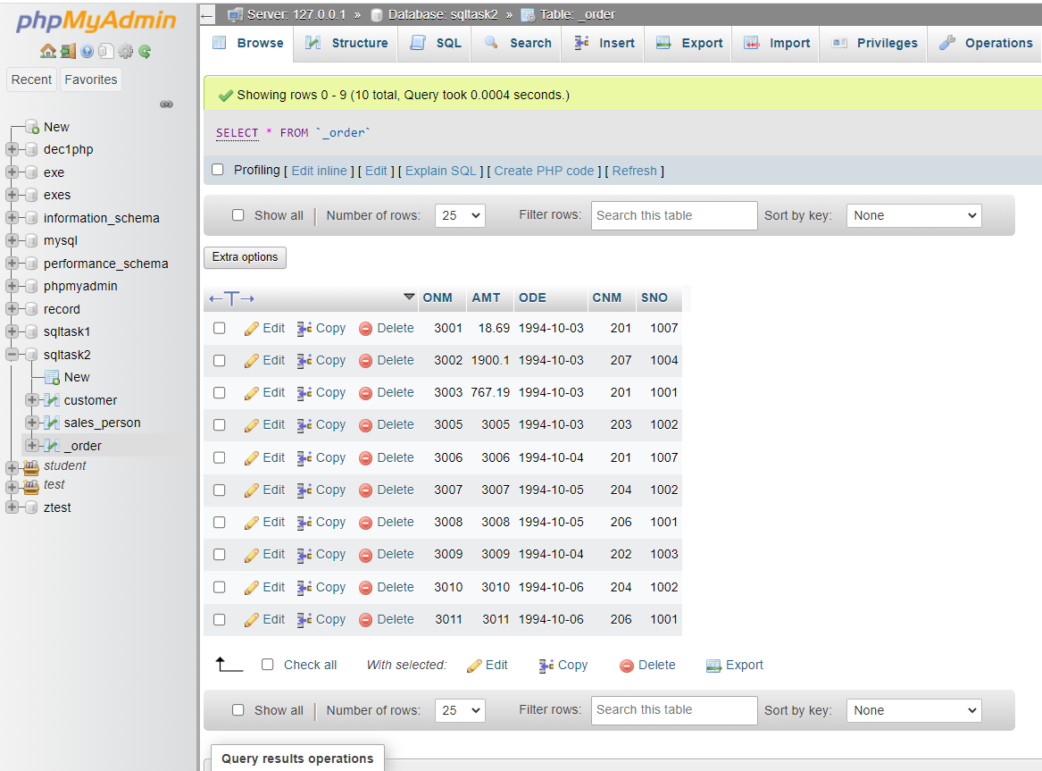

--------------------------------------QUESTION-------------------------------------------

a) All orders for more than $1000.

Ans: **SELECT** * **FROM** _order o **WHERE** o.AMT >1000 ;

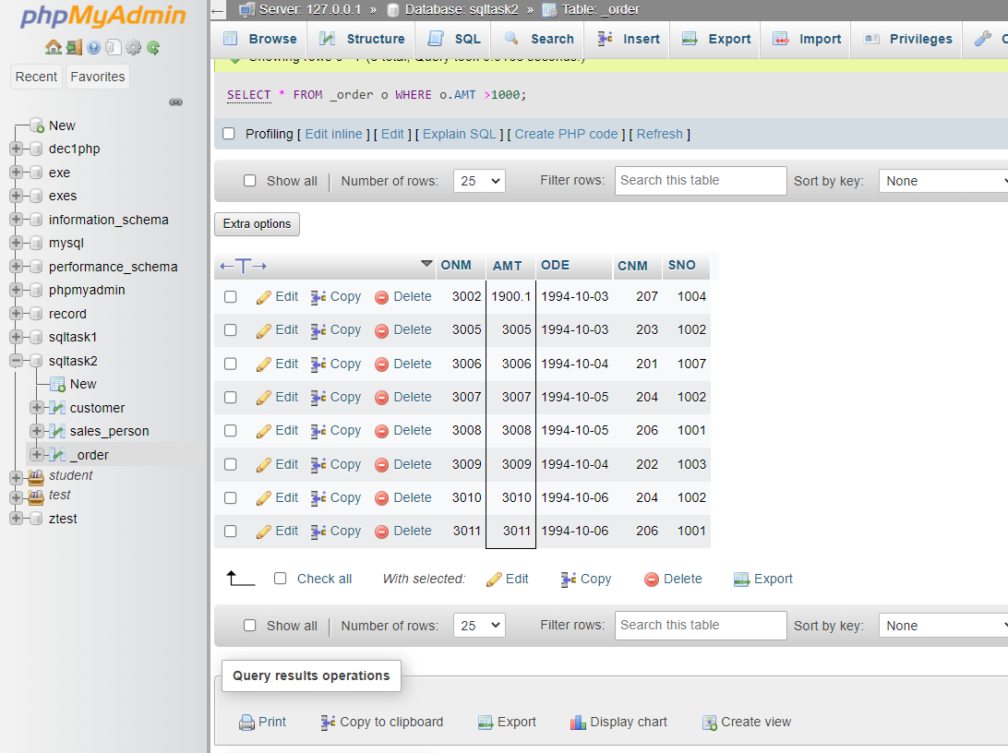

b) Names and cities of all salespeople in London with commission above 0.10.

Ans: - **SELECT** s.SNAME,s.CITY **FROM** sales_person s **WHERE** comm > 0.10 **and** CITY=

'LONDON';

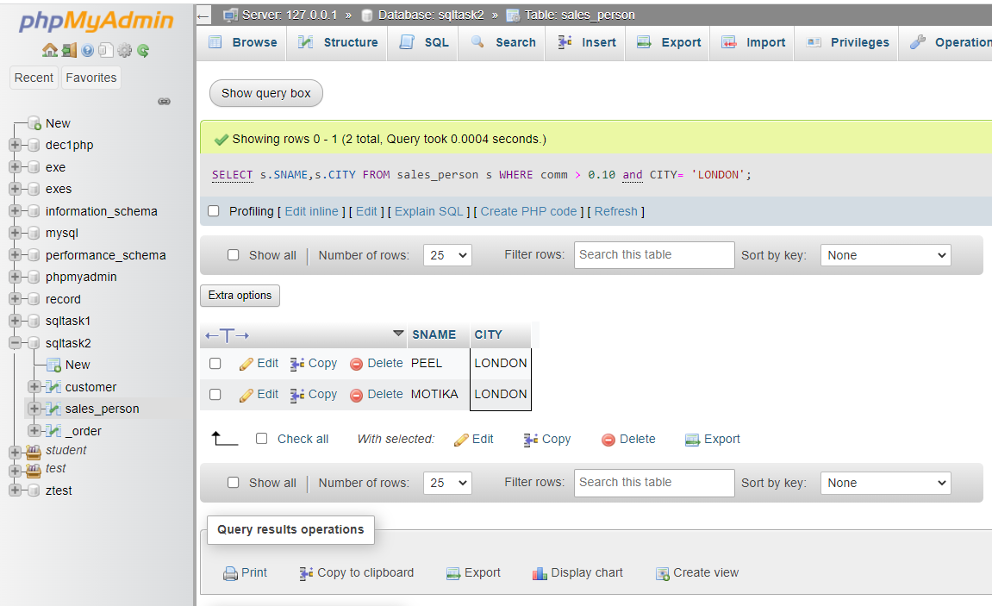

c) All salespeople either in Barcelona or in London.

Ans: - **SELECT** s.SNAME,s.CITY **FROM** sales_person s

**WHERE** s.CITY **IN**('BARCELONA','LONDON');

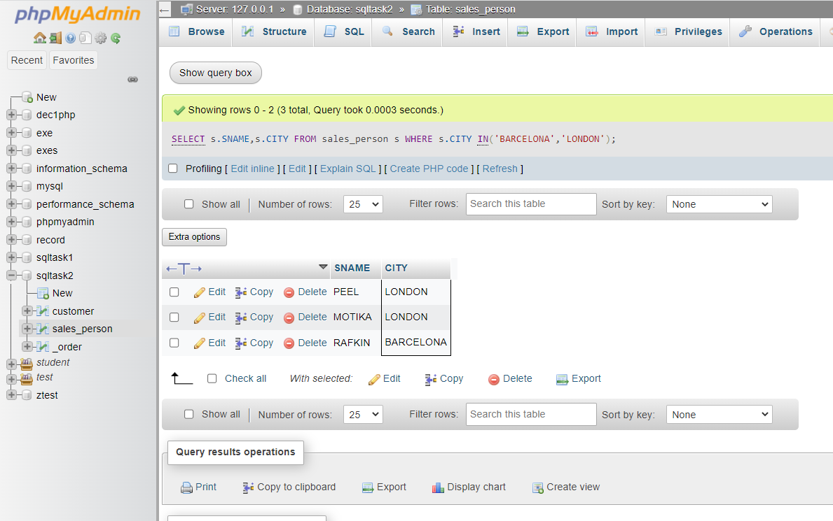

d) All salespeople with commission between 0.10 and 0.12. (Boundary values should be excluded).

Ans: - **SELECT** SNAME,COMM **FROM** sales_person **WHERE** COMM > 0.10 **AND** COMM <0.12;

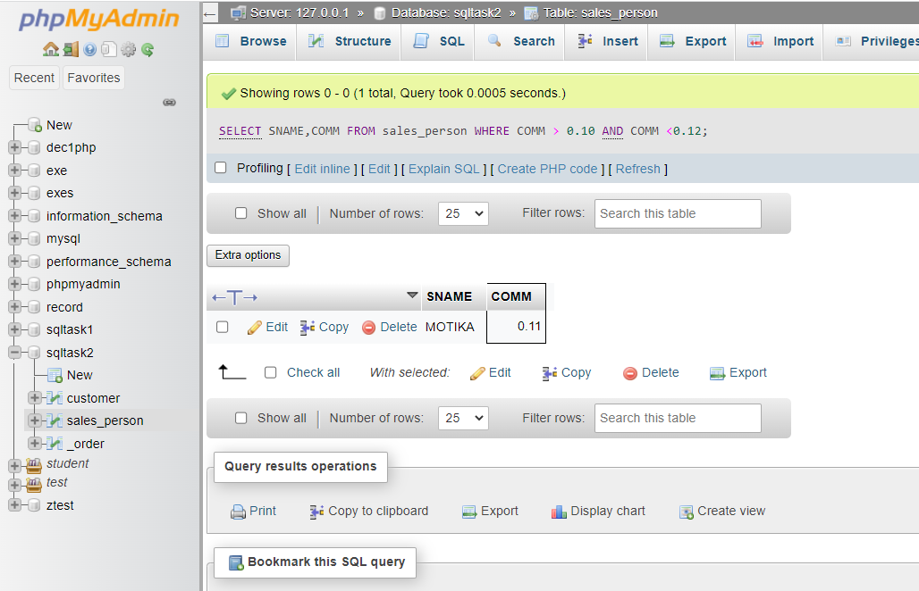

e) All customers with NULL values in city column.

Ans: **SELECT** CNAME **FROM** customer **WHERE** CITY **IS** **NULL;**

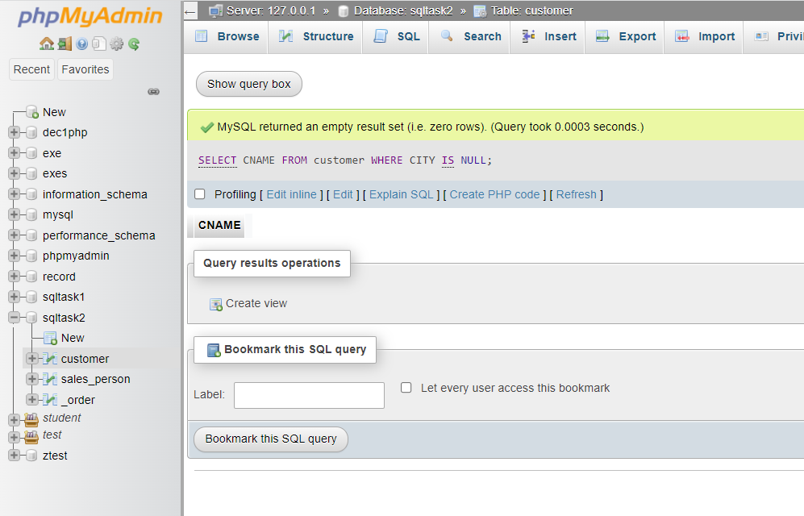

f) All orders taken on Oct 3Rd and Oct 4th 1994.

Ans: **SELECT** * **FROM** _order **WHERE** ODE **IN** ('1994-10-03','1994-10-04');

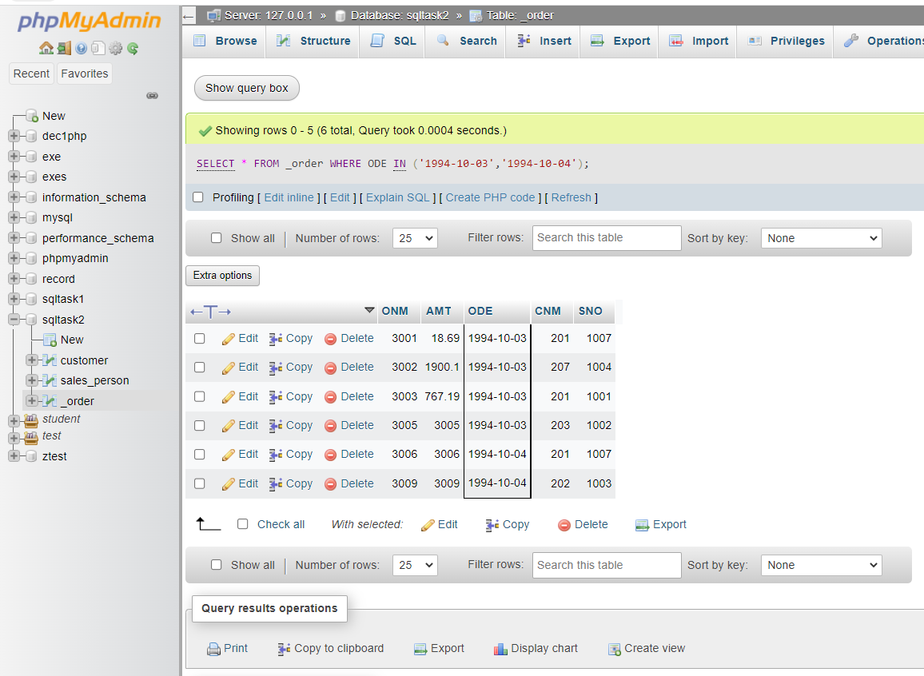

g) All customers serviced by peel or Motika.

Ans: - **SELECT** * **FROM** customer **WHERE** SNO **IN** (1001,1004);

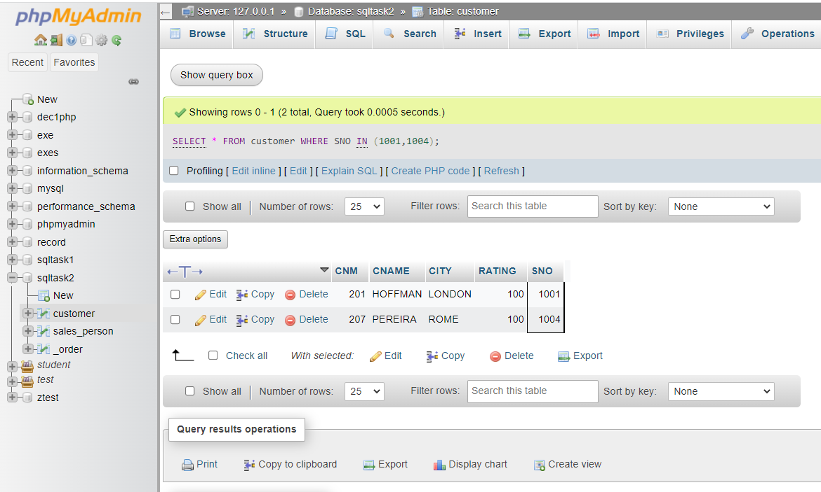

h) All customers whose names begin with a letter from A to B

Ans: - **SELECT** * **FROM** customer **WHERE** CNAME **LIKE** 'A%' **OR** CITY **LIKE** 'B%';

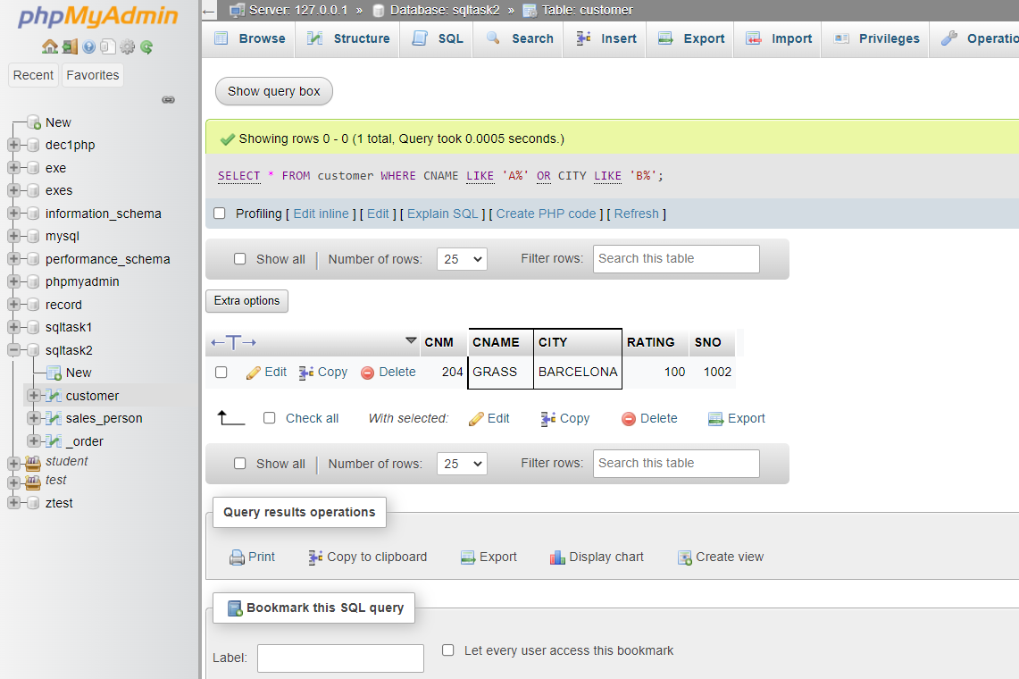

1. All customers excluding those with rating <= 100 unless they are located in Rome.

Ans: - **SELECT** * **FROM** customer **WHERE** RATING <=100 **AND** CITY ='ROME';

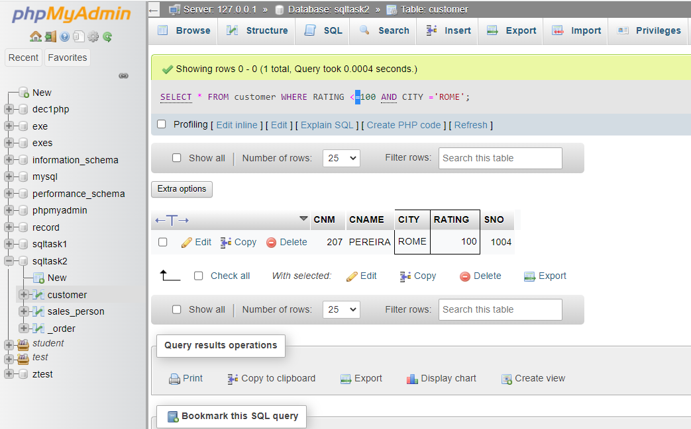

j) All orders except those with 0 or NULL value in amt field.

Ans: - **SELECT** * **FROM** _order **WHERE** AMT **IS** **NOT** **NULL**

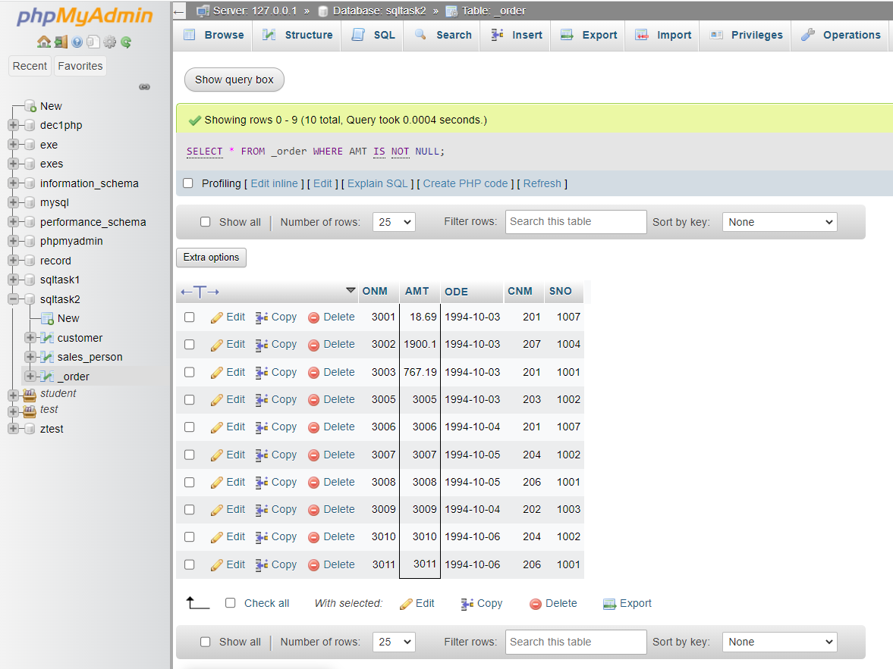

k) Count the number of salespeople currently listing orders in the order table.

Ans: - **SELECT** **COUNT**(**DISTINCT** SNO) **AS** SNO **FROM** _order;

